**1. A concise introduction to your team and the project.**

Hi, this is team number 6 from the Robots to Rescue project. Our team member consists of Zhaoyu and Arya in computing stream, Selina and Michael in manufacturing streams and Adam will take care of the electrical stream. (15 seconds)

**Final Problem Statement**

Inspired by the RoboCup competition, the project aims to design a tele-operated rescue robot that shall be capable of navigating through a complex environment of rough terrains, maze walls, and stairs ranging from 6mm to 36mm whilst avoiding collisions to locate and extract a single survivor represented by a tennis ball. The robot must locate the victim and report back to the operator before transporting it back to the starting location. The Robot will be powered by an Arduino uno microcontroller that allows the operator to remotely control the robot’s actions. Furthermore, the robot must be able to fit inside a cylinder 250mm diameter and 250mm height and must weigh less than 1000gm. The entire build from scratch must cost under $120 and comply with the time constraints. (50 seconds)

**2. A brief discussion of the importance of the problem definition design phase.**

The problem definition is an extremely important phase to the team as it ensures that all problems are accounted for which can prevent contingencies later in the project leading to less time and money wasted. Clarity of purpose ensures that it is clear what is wanted to be achieved leading to zero confusion and goals able to be set, thus leading to team members developing a mutual understanding towards the project.

However, risk mitigation is the ability to understand that certain risks are involved with any design and is necessary to prepare a team for any setbacks. Furthermore, knowledge about the limitations and requirements the finished designed product must meet ensures that designs are not made that do not meet the measurable success criteria, hence the finished product will meet restrictions such as size and weight.

Ethical and safety considerations must be considered also to guarantee the safety of team members and the ethical impact the design materials have on the world. This all leads to well thought design decisions which leads to good operational efficiency and recourse allocation, thus resulting in no wasted time and money. This is further reinforced by the idea that this can prevent future mistakes in the design resulting in less or no backtracking in the design process, therefore showing the importance of the problem definition design phase.

**3. A justification of the quality of your team’s problem statement. (Aryaman Sakthivel)**

**Slide 1: Title and Introduction**

**Justification of Problem Statement for Rescue Robot Project:**

I'll present the justification for our rescue robot project's problem statement. We've carefully considered various aspects:

**Slide 2: Clarity and Relevance**

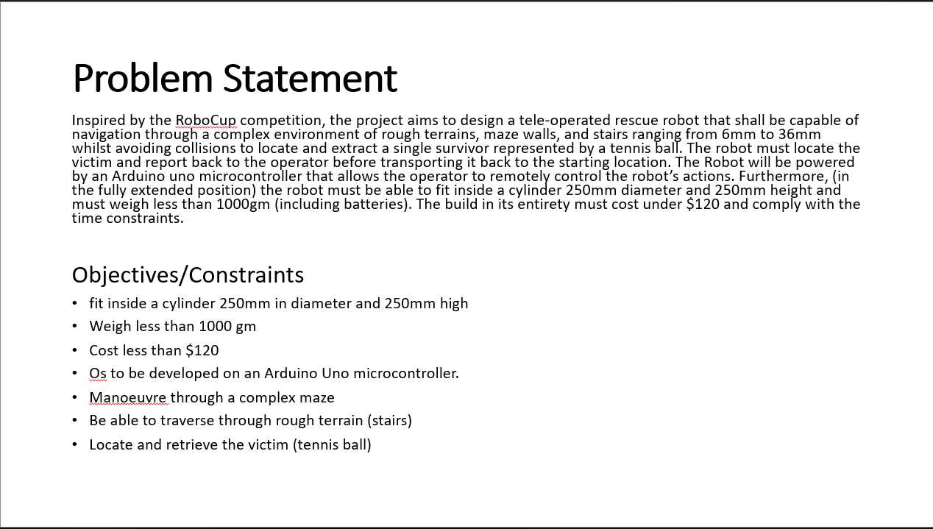

(Clarity)

Our problem statement is clear: “the project aims to design a rescue robot that shall be capable of navigating through a complex environment of rough terrains to locate and extract a single survivor represented by a tennis ball.

**(**Relevance**)**

Retrieving a tennis ball may seem simple, but it's a fundamental step in more complex missions. Our project's relevance contributes directly to our broader objectives of advancing robotic capabilities.

**Slide 3: Comprehensive Problem Definition**

(Comprehensive Problem Definition)

Our problem statement goes beyond surface-level challenges. It encompasses various dimensions, including mechanical design, sensor integration, and control algorithms. This comprehensive approach ensures our robot can address a wide range of challenges.

**Slide 4: Success Criteria and Risk Consideration**

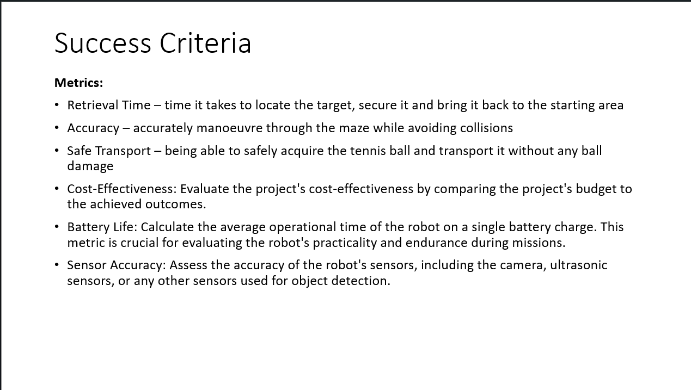

(Measurable Success Criteria)

We've set clear metrics, such as retrieval time, accuracy, and transport safety to guide our progress and evaluate success upon completion.

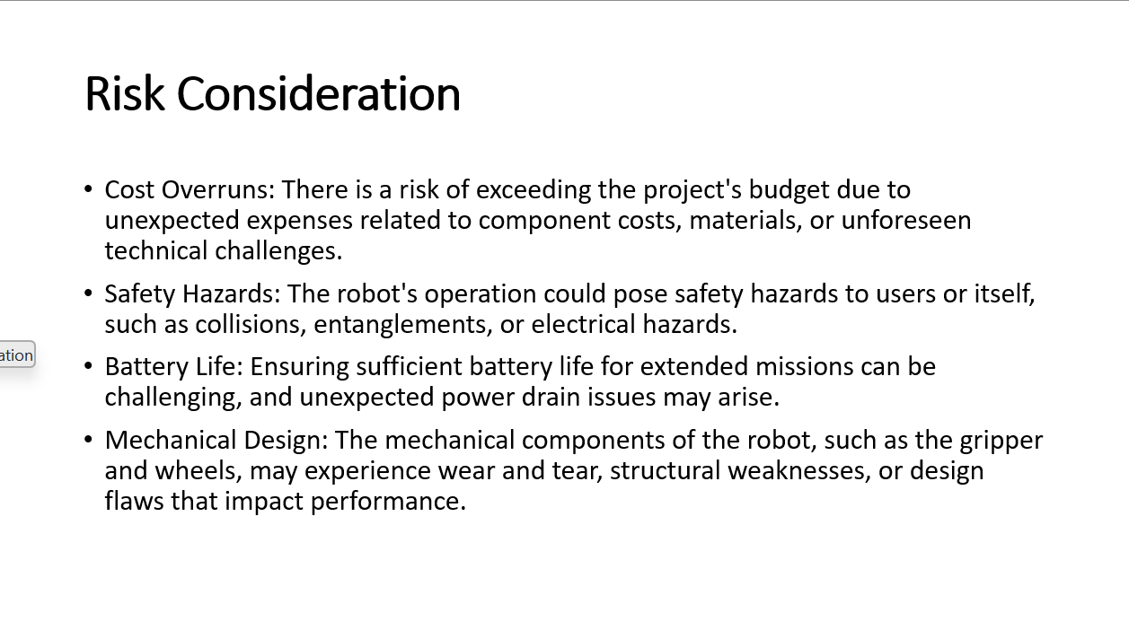

(Risks)

We've identified and mitigated risks, including technical challenges, size and budget constraints as well as safety concerns.

**Slide 5: Resource Planning**

Meticulous resource planning ensures efficient allocation of components, materials, software tools, and human resources, helping us stay within budget and schedule.

**Slide 6: Innovation and Technology Integration**

Our problem statement encourages innovation and technology integration. We explore cutting-edge technologies such as Arduino microprocessors and different sensors to keep our robot at the forefront of advancements.

**Slide 7: Conclusion**

In conclusion, our problem statement for the rescue robot project covers clarity, relevance, comprehensiveness, measurable criteria, risk management, resource planning as well as innovation.

It guides our focus, ensuring we deliver a robot that excels in its mission. (1:50)

**4. A justification of the quality of your team’s requirements matrix (Selina)**

The quality of the team requirements matrix serves as a critical factor in ensuring the success and efficiency of a project, particularly in our context of developing a rescue robot. The quality aspects of our requirements matrix involves directly aligning the goals, objectives and constraints in the project as outlined in the design project brief provided by the client. This alignment ensures that the requirements are focused on the essential features and functions. Furthermore, by directly deriving the requirements from the client's project brief, our client centric approach ensures that the project remains focused on meeting the client's specifications. (37)

Each requirement in the matrix is accompanied by a clear and specific description that leaves no room for ambiguity. This clarity is essential in preventing misunderstandings and ensuring that all team members and stakeholders have a shared understanding of the project's requirements. (30 seconds)

To ensure no critical aspect of the project is overlooked, our requirement matrix ensured comprehensive coverage of a wide range of requirments from physical dimensions and weight to technical functionalities, and performance metrics. Through this, we are able to identify the dependencies and interconnectedness between those aspects and this is crucial as it highlights the interplay of different features and functions, allowing the team to prioritize and address these connections during the design and development phases. (25)

This was followed by robust and varied verification and validation methods for each requirement, encompassing analysis, testing, demonstration and inspection to ensure that the requirements are not only specific but they are also measurable and verifiable. This level of detail in our requirements matrix was crucial for tracking progress and confirming compliance throughout the project. ((18)

Thus, we strived to construct a quality team requirements matrix as it is comprehensive, client-centric, clear and supported by well-defined verification methods. These characteristics are essential for guiding the project effectively, facilitating collaboration among team members, and ultimately delivering a successful rescue robot prototype. (20 seonds)

**5. A brief discussion of the importance of the conceptual design phase.**

Next, I will be discussing the importance of the conceptual design phase, which is crucial to two important factors of an engineering project – Cost and Stakeholder communication.

1. Cost saving

Cost saving is one of the most important aspects of conceptual generation. All engineering projects have limited budgets with prototyping and production the most expensive as shown by the graph below. Georgiou and Haritos (2012) support this claim with their statement “90% to 95% of product costs are committed with late design changes”. They further conclude that “The early advanced phase of product development is one of the most critical and influential aspects in defining the specification and conceptual design of new products”. Therefore, without conceptual generation prior to prototyping, any subsequent changes to the prototype and production will be costly. Hence, conceptual generation is a cost-effective way of exploring alternative designs with minimal costs. (55 seconds)

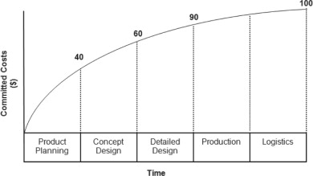

Figure 1. Committed Costs (Georgiou and Haritos, 2012)

1. Secondly, the conceptual design phase facilitates clear communication among all stakeholders. All engineering projects involve multiple stakeholders – Investors, Management, and Engineers. Generating design concepts is the most effective way of determining whether a design satisfies clients’ requirements. As Neumann, Riel, and Brissaud (2011) assert: “the success of the product development process heavily depends on the input to the innovation management”. The is directly correlated to design concepts generation, as they are the most efficient method of soliciting consistent feedback from management and/or investors, with effective input given for every iteration of design concepts. (48 seconds)

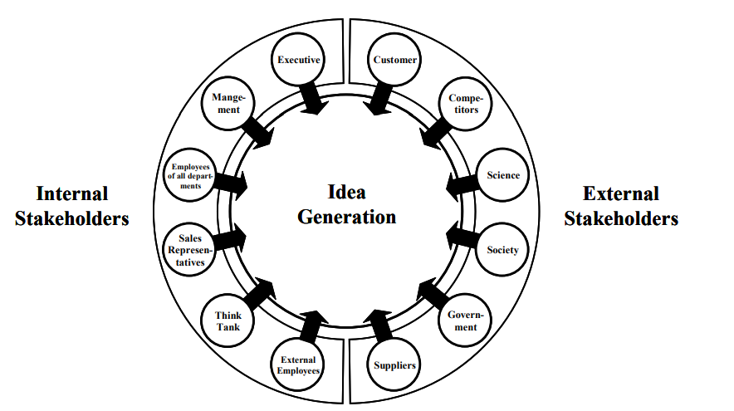

Figure 2 Innovation management system based on the integration of stakeholders (Neumann, M., Riel, A. and Brissaud, D 2011)

Institution of Mechanical Engineers (2012). *Sustainable Vehicle Technologies*. Elsevier.

Neumann, M., Riel, A. and Brissaud, D. (2011). Sustainable innovation management in the automotive supplier industry. *International Journal of Technology Intelligence and Planning*, 7(4), p.327. doi:https://doi.org/10.1504/ijtip.2011.045093.

**6. A discussion of the concepts generated by your team, including the concept generation tools used and annotated sketches. (Selina)**

In the process of creating our rescue robot, we recognized the significance of exploring a wide range of ideas. To achieve this, we employed multiple concept generation techniques, such as the gallery method, 6-3-5 brainstorming sessions, mind mapping, Morth chart as well as the story boarding method.

One approach we adopted was the gallery method, an individual idea generator where each team member was given a set amount of time to independently brainstorm and sketch their initial design ideas. Thus allowed us to share and gather feedback on design sketches, facilitating individual idea generation and emergence of unique concepts. The feedback received from this method directed us to our next technique.

We then embraced brainstorming in a free-flowing and non-critical environment. This approach encouraged creativity and collaboration, essential for generating innovative concepts. Following brainstorming, we turned to mind mapping . By constructing a visual representation of the concepts and their relationships, highlighting the holistic picture of the robot design.

Storyboarding played a pivotal role in our concept generation process. By creating a visual narrative of our robot's operation, we could brainstorm solutions for how it interacts with its environment and addresses challenges during rescue missions. Storyboarding enabled us to break down the robot into its fundamental attributes, before we moved those features to a morph chart matrix and attempted to generate more fundamental components relevant to the robot's functionality. By systematically mixing and matching these attributes, we experimented with unexpected combinations to derive fresh and innovative solutions.

The robot's main body will consists of a modular chassis made from lightweight and durable materials. The wedge shaped wheels will enhance traction, distribute the robot’s weight more effectively whilst improving climbing ability. We also emphasised on using a retrieval mechanism to grab and store the tennis ball instead of using arm like designs to simplifies the robot's build and operation in addition to making efficient use of space, conserve weight, and ensure reliable and safe rescue operations.

Throughout this journey, we continuously discussed and experimented with these concept generation techniques. The result has been a dynamic and evolving process, leveraging the combination of these methods to create a diverse range of ideas for our rescue robot project.

**(1:20seconds)**

**7. A concise conclusion, including your team’s next steps for the project.**

In conclusion, on a longer time frame the advancement in large walking robots could eventually be a significant game changer. Not only could these system help find people but would be able to physically carry them out of danger.

The value of improved search and rescue technology can’t just be thought about in terms of the number of lives it saves. While that is hugely important, the improvements are going to impact millions of people. Being able to quickly map and assess damage can help a community rebuild and recover much faster.

(43)